Chemical Engineering Division
Executive Committee Meeting - Boston, Massachusetts
Monday November 8, 2021
No one to take minutes; will use slides and my (Tony’s notes).
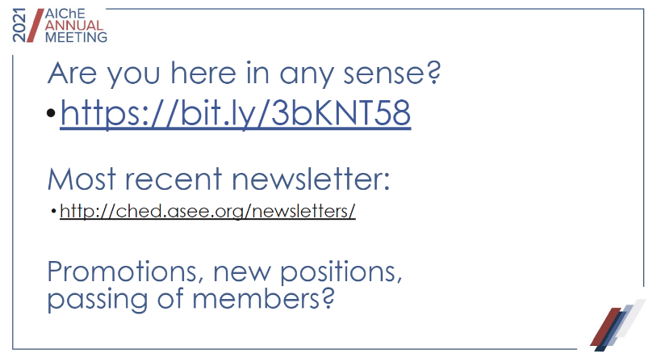
Roll call:
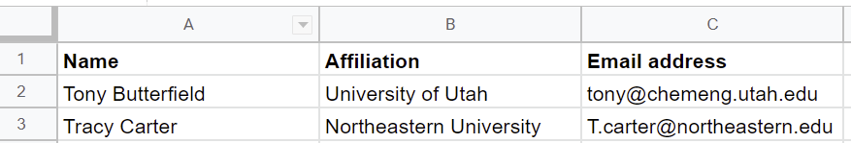
Chris Barr | University of Michigan
Janie Brennan | Washington University St. Louis
Matthew Cooper | North Carolina State University
Ashlee  Ford Versypt | University at Buffalo
Fernando Merida | University of Florida
Reg Rogers | University of Missouri
David Silverstein | University of Kentucky
VJ Tocco | University of Florida
Bernie Van Wie | Washington State
Margot Vigeant | Bucknell University
Sarah Wilson | University of Kentucky
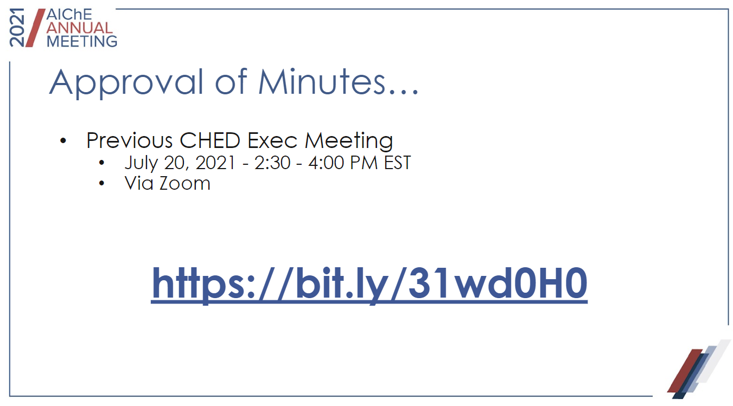

Summer exec committee minutes approved unanimously.

Finances:
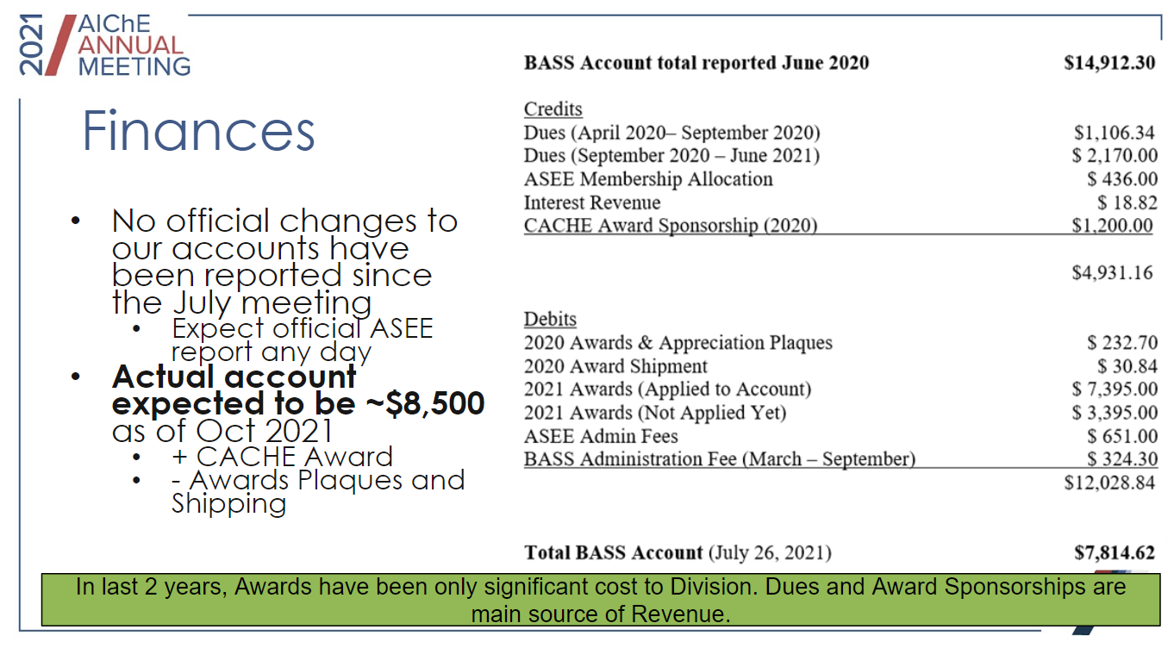
Membership updates:
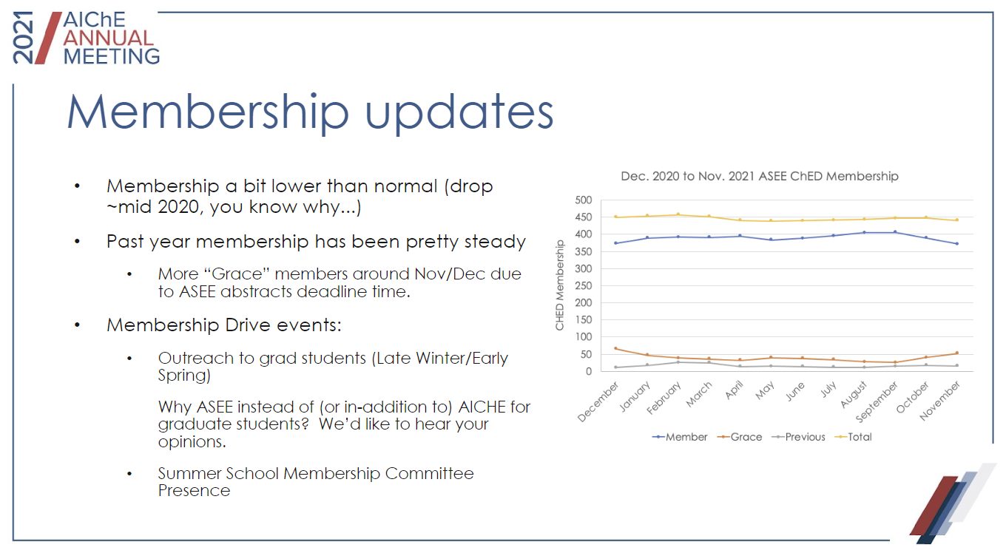
Awards update:
- Seeking to update descriptions and amounts officially
- Happy thing - there is sponsorship (THANK YOU Bernard & Fernando! And especially Gamry Instruments!)
  - Tony will add sponsor to site.
- Seeking nominations for: Fahien, CACHE, Lifetime, Travel/Mentoring

Proposed changes to awards:
Item 1: Alter the text of the division website to eliminate the monetary value from awards, listing only an “honorarium” or, in the case of the travel award, “registration and some funding towards travel”.

Item 2: Add “honorarium” to both the Martin (ASEE ChED best paper) and Best Poster awards on the division website.

Item 3: Adopt the website language as the official awards description language to be used on the ASEE awards websites.

Item 4: Adopt the following language as procedure for the awards co-chairs and subcommittees. Note this will supersede existing language on subcommittee composition.

The awards committee co-chairs or chair will convene one subcommittee for each division award. The default committee consists of three members, including at least one of the co-chairs and one or two members of the ASEE ChED executive board, with the addition of the Chemical Engineering Editor (or their designee) for the Corcoran award. Directors will be the first choice for additional subcommittee members, with the stipulation that the each subcommittee should be constructed in such a way as to balance the workload across the executive committee and avoid conflicts of interest (see below). If needed, recent past members of the executive board may be asked to step in when no other suitable subcommittee members are available. The subcommittee will follow established procedures and should use a rubric to aid in fair evaluation of all candidates. The rubrics will be maintained and updated by the awards chair / co-chairs.

The awards subcommittees will avoid conflicts of interest by recusing any potential members who: 1) are under consideration for the award 2) nominated a candidate for the award 3) are a collaborator or department-mate of a candidate for the award 4) for any reason feel they cannot be make a fair evaluation (ex: because they are a close friend of a nominee). For the non-nominated best paper / best poster awards, a potential subcommittee member may serve by first removing their paper / poster from consideration. Having a conflict of interest for one subcommittee does not preclude an executive board member from serving on a different subcommittee.

Changes were unanimously approved. Tony will make changes to the awards chair duties on the web site.

Summer School:
- Programming proposals closed, all submissions under consideration
- Attendee registration to open end of year/ early 22
- Fundraising is underway

ASEE Conference:

Tony has been getting many requests to push the paper deadline back, but he does not have that power, and made the request to Jacqueline. Jacqueline reported back that she will push the deadline back to Nov. 15, moved the review phase to Nov. 29 (instead of Nov. 22).

Currently we have 23 abstract submissions on Slayte.

Web Site:

Tony requested a web site co-pilot to help manage the site during his year as chair, but there were no takers.

New Business:

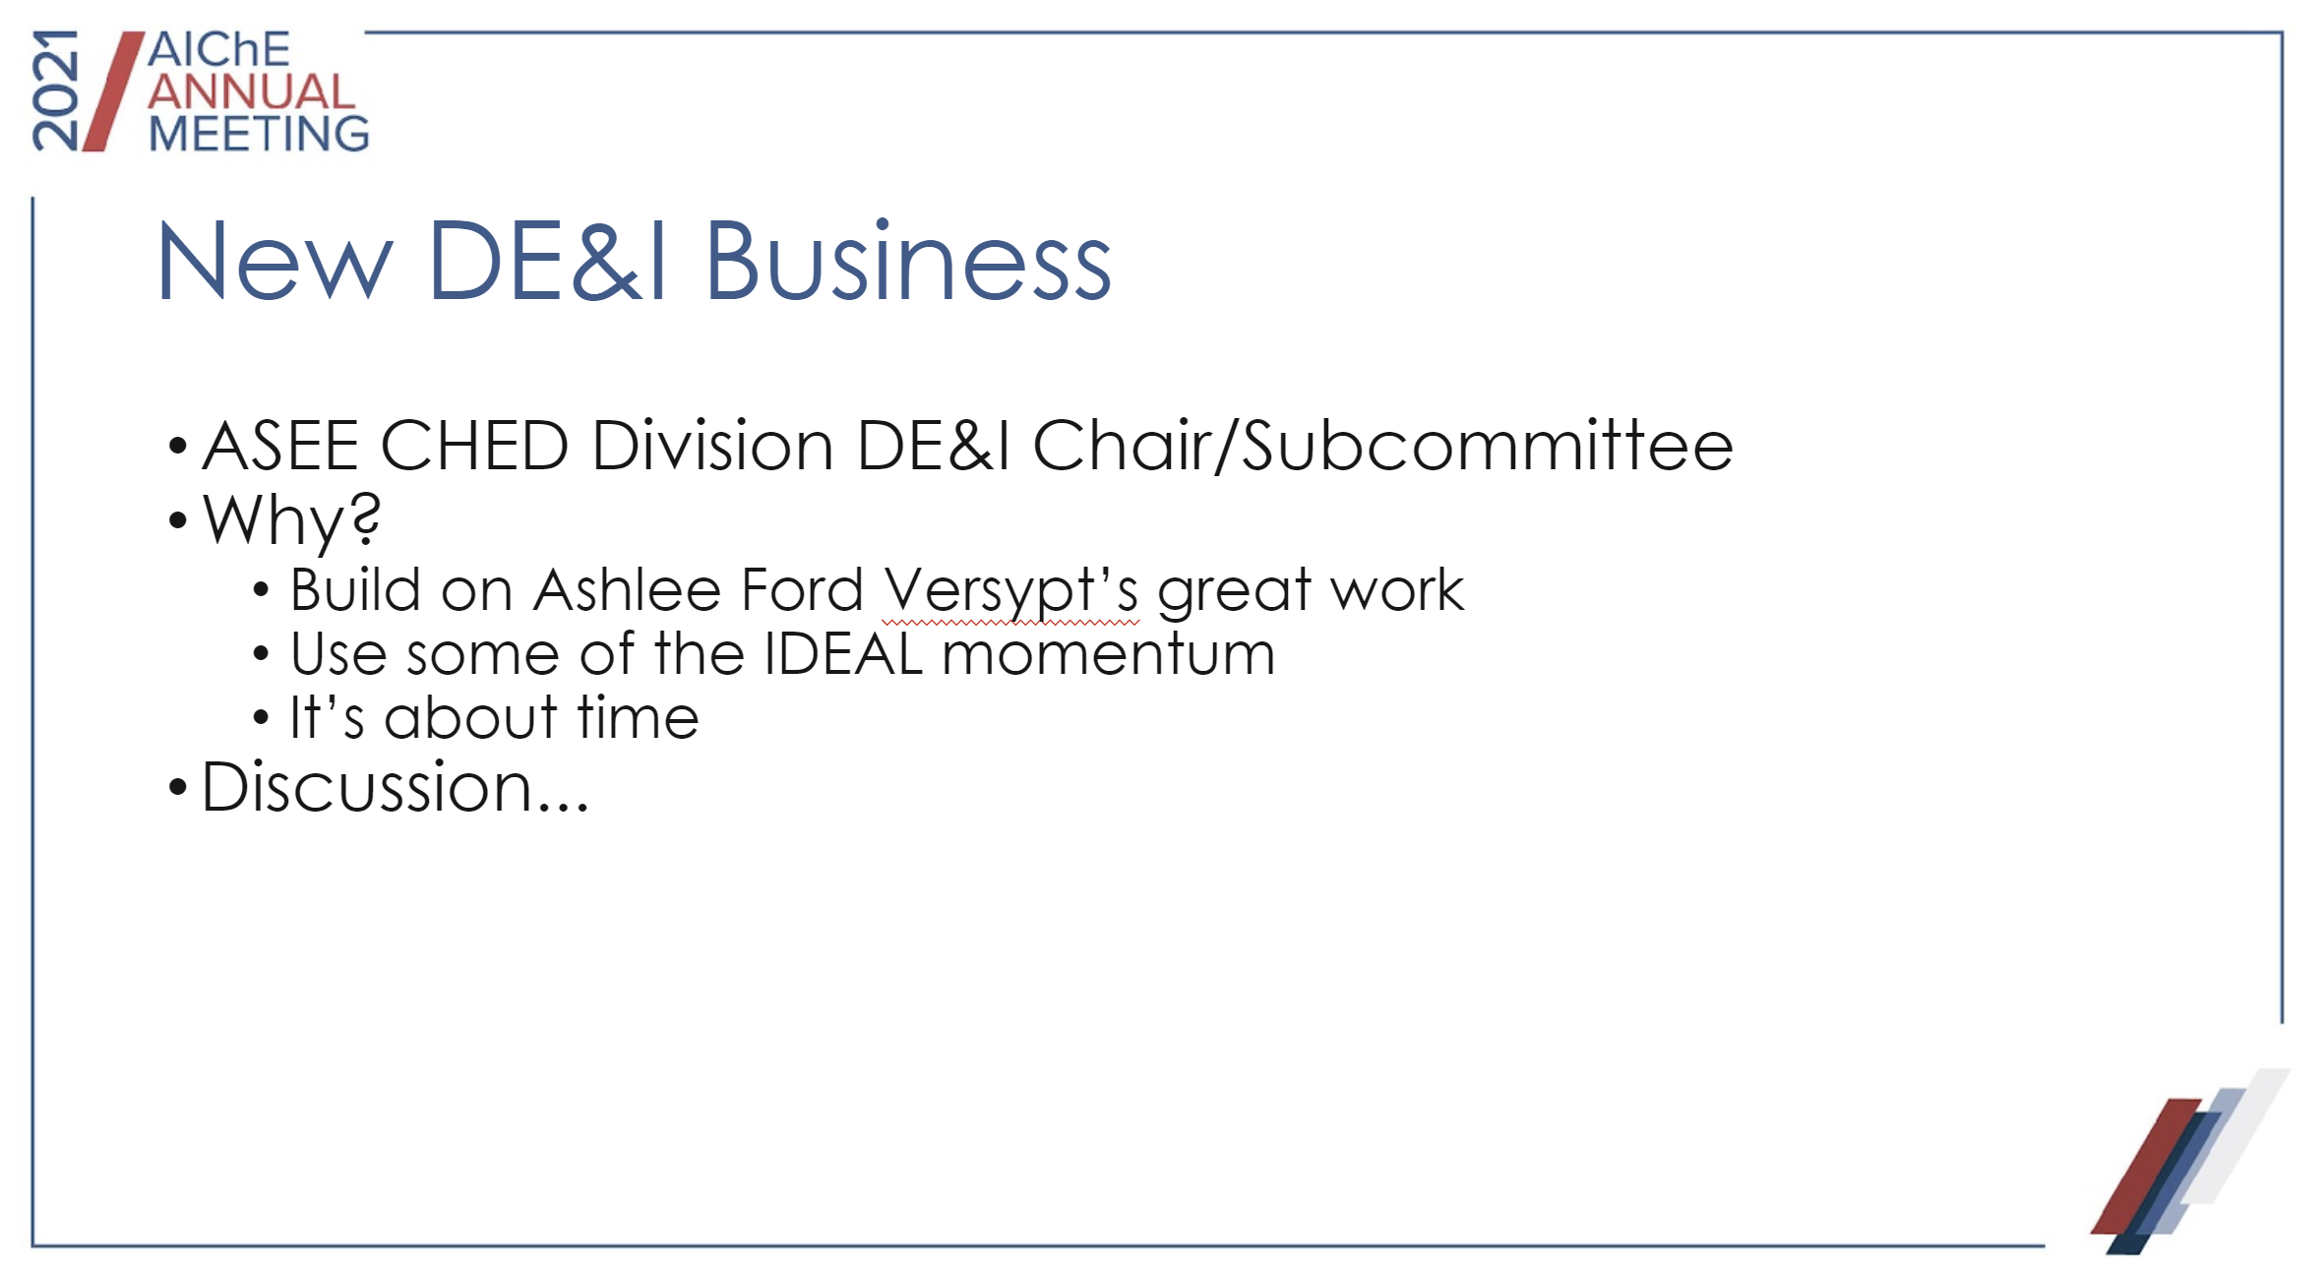
Tony proposed to initiate a DE&I Division Subcommittee. The group was unanimously supportive.

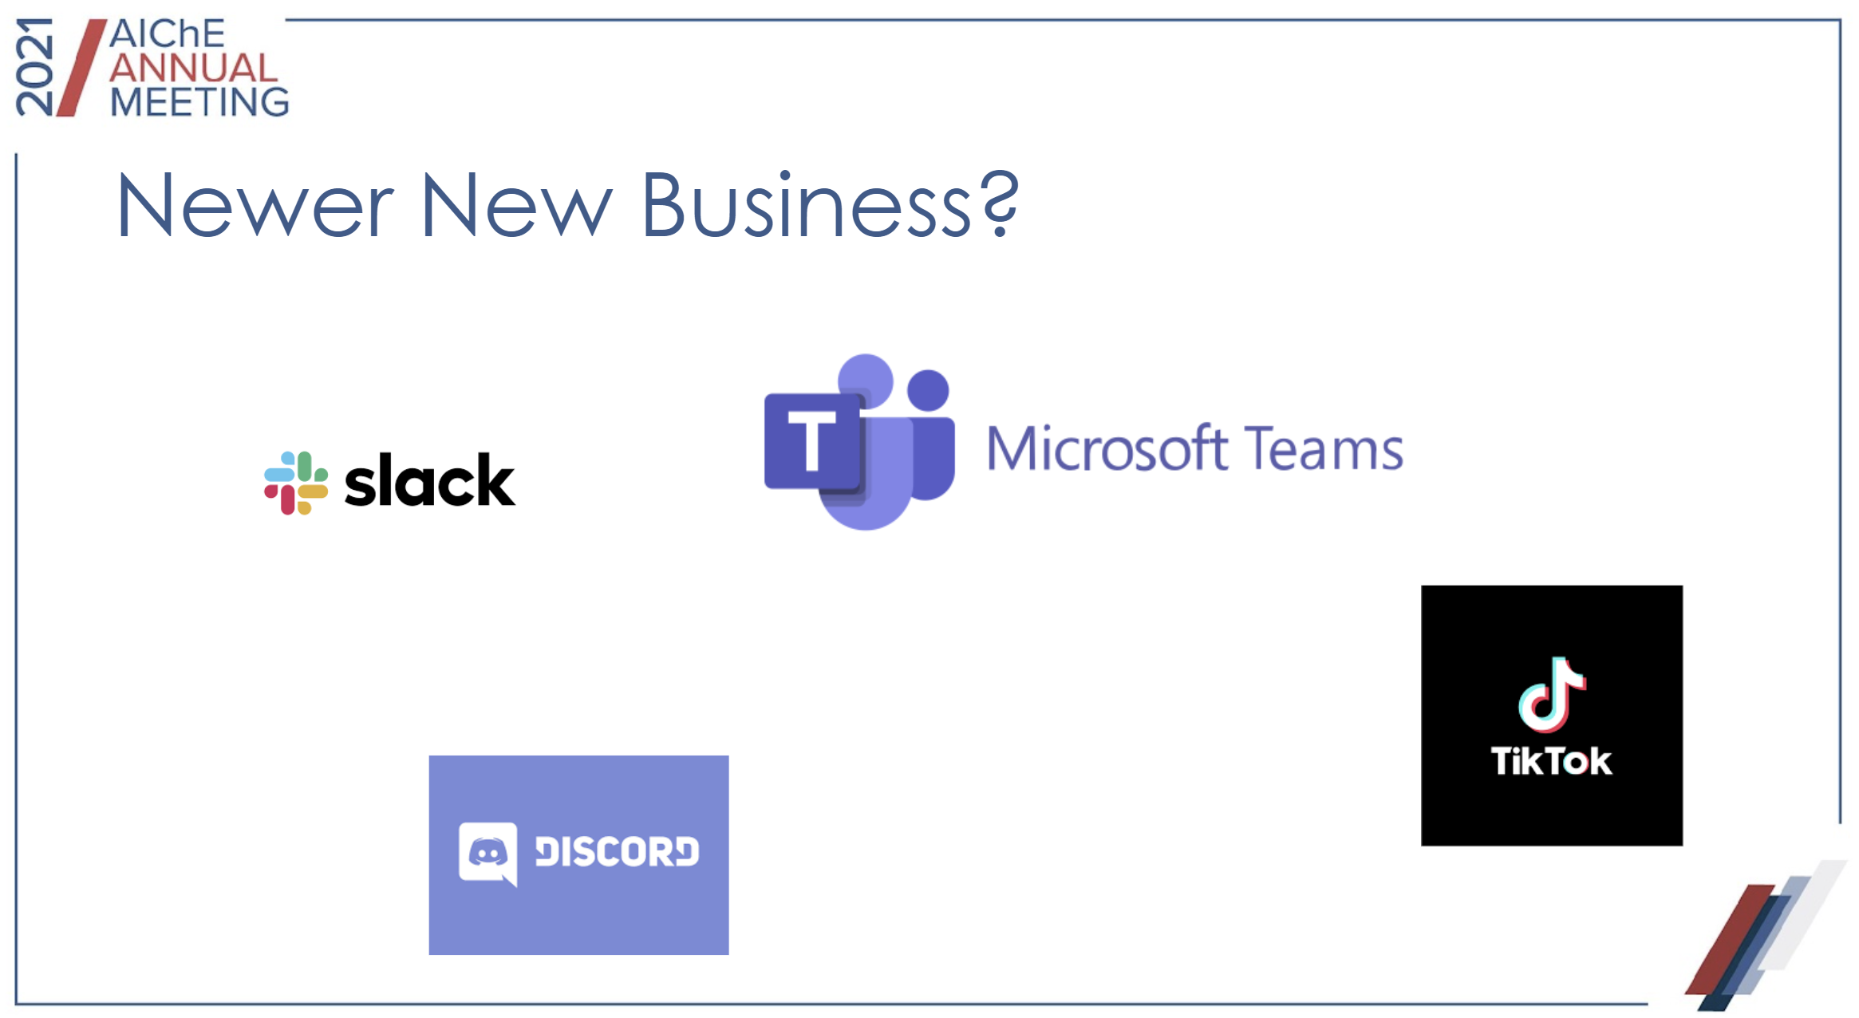

Tony also wanted to gauge is the division should reconsider how they keep in contact with division members. There was no consensus on what social media platform would be best, if any. Tony will send out a poll to the division members to gauge interest on how best to reach members.

