CHEMICAL ENGINEERING DIVISION
Executive Committee Meeting Minutes
Tuesday, June 23rd, 2021 – 3:30 pm – 4:30 PM
Online (via Zoom)

- Board Update
  - Award nominations were down this year (will be video for using new system for nominations)
  - Future HQ-hosted events will require vaccines if in person
    - Out of an abundance of caution for our staff and their families, for in-person meetings that ASEE staff will attend, ASEE will require staff, members, participants, and guests to attest that they’ve been vaccinated for COVID-19. Those who can’t or choose not to be vaccinated may or may not be able to be accommodated at the meeting.
  - Future conferences will have recommended local charity links to encourage P-12 and DEI
  - Ethics committee was formed last year and adjudicated 2.5 cases
    - Abstract review
    - Self-Plagiarism
    - Meeting conduct
  - New Committee on Scholarly Publications. Scope to include JEE and AEE, as well as division-led journals.
    - Division representatives will be included in the committee.

- PIC Updates
  - PIC Bylaws were approved in FY 2021
  - Distinguished Lecture proposal evaluation rubric has been updated.
  - Interdivisional Town Hall Committee has been formalized and restructured.
  - ASEE Reviewer Expectations created

- New distinguished Lecture Proposal Rubric
  - 1. The degree to which you believe the proposed speaker(s) has the appropriate expertise to present the topic in an elevated session at the Annual Conference. (Likert 1 - 5)
  - 2. The degree to which you believe the topic is of interest to the community. (Likert 1-5)
  - 3. The degree to which you believe the topic is necessary/beneficial to the community. (Likert 1-5)
  - And for discussion: How similar is the content of each proposal is similar to other proposals?
- Conference updates:
  - Number of Attendees: 3110 (3263 in 2020)
  - Number of Published Papers: 1713 (1762 in 2020)
  - Number of Unique Authors:1374 (1423 in 2020)
  - The conference venue will be available to registered attendees for up to a year.
    - Presentations will be available as “view only” and are not downloadable.
    - A link will be made available on the Annual Conference 2021 to direct attendees back to the virtual conference platform.
    - We are planning on an in-person meeting in Minneapolis.
    - ASEE is launching a new Paper Management System for the 2022 conference.
    - The new system is scheduled to launch in late September 2021.
    - This means that abstracts won’t be due until October 2021.

- Financial Update
  - Membership (as of Q2):
    - Institutional (Academic): +0.7%
    - Institutional (non-Academic): -17.39%
    - Individual: -2.7%
  - Financial Status:
    - We are cautiously optimistic about the FY21 budget. There is a $600K shortfall from the Annual Conference income (again this year).
    - ASEE’s first PPP loan from the government has officially been converted into a grant. ASEE has received a second PPP loan as well. To date, ASEE has not had to furlough any staff.

- Chemical Engineering Division Programming - VJ Tocco
  - 7 Technical sessions (4-6 papers/session)
    - “Learning Outcomes and Assessment within Chemical Engineering”: Monday 1:15 – 2:45 PM
    - “Experiential Learning in Chemical Engineering”: Monday 3:00 – 4:30 PM
    - “Works in Progress in Chemical Engineering Education”: Tuesday 9:45 -11:15 AM
    - “Teaching Professional Skills in Chemical Engineering”: Tuesday 11:30 AM – 1:00 PM
    - “Chemical Engineering Pedagogy”: Wednesday 8:00 – 9:30 AM
    - “Business and Professional Literacy within Chemical Engineering”: Wednesday 3:30 – 5:00 PM
    - “Virtual Instruction of Chemical Engineering Courses”: Thursday 8:00 – 9:30 AM
  - 2 Special Sessions
    - “Promoting Mental Health and Wellness in Undergraduate Engineers”: Tuesday 3:30 – 5:00 PM
    - “Inclusion in Chemical Engineering: Reflections From the Conversation Series on Inclusion and Thriving”: Wednesday 1:45 – 3:15 PM
  - 1 Poster Session (Only 2 Submissions ) Wednesday 9:45 – 11:15 AM
  - 2 Donald Woods Lectureship Award for Lifetime Achievement in Chemical Engineering:
    - Milo Koretsky: Thursday 11:30 AM – 1:00 PM
    - Taryn Bayles: Thursday 3:30 – 5:00 PM
  - 1 Business Meeting: Tuesday, 1:45 – 3:15 PM

- Award winners:
  - Joseph J. Martin Award - Best paper at ASEE 2020
  - “Using Incident Reporting to Integrate Hazard Analysis and Risk Assessment into the Unit Operations Lab”
    - Sarah Wilson
    - Samira Azarin,
    - Chris Barr,
    - Janie Brennan,
    - Tracy Carter
    - Amy Karlsson
  - William H. Corcoran Award - Best paper in CEE 2020
  - “Revealing the Decision-Making Processes of Chemical Engineering Students in Process Safety Contexts”
    - Cheryl Bodnar
    - Emily Dringenberg
    - Brittany Butler
    - Daniel Burkey
    - Daniel Anastasio
    - Matthew Cooper
  - Thomas and Donna Edgar CACHE Award - Computer Learning Aids for ChemE
    - John Falconer
  - Raymond W. Fahien Award - Early Career ChemE Scholar & Educator
    - Elif Miskioglu
  - Donald R. Woods Lectureship for Lifetime Achievement in Chemical Engineering Pedagogy
    - Taryn Bayles
    - Milo Koretsky

- Proposed awards changes
  - Make the current ChED website text the official text with the following change:
  - Remove all award amounts
  - Rectify discrepancies between ASEE/CHED and CHED awards webpages
  - Designate the ChED exec committee as the source of subcommittee members (3 each) for each individual award
(with CEE editor for Corcoran)
  - Adopt the idea of a rubric for evaluation of nominations
  - Adopt a conflict of interest policy for the award subcommittees
  - Doc: Awards Changes for Voting.docx

- Membership:
  - Recruitment activity: Reached out to those attending ASEE 2021
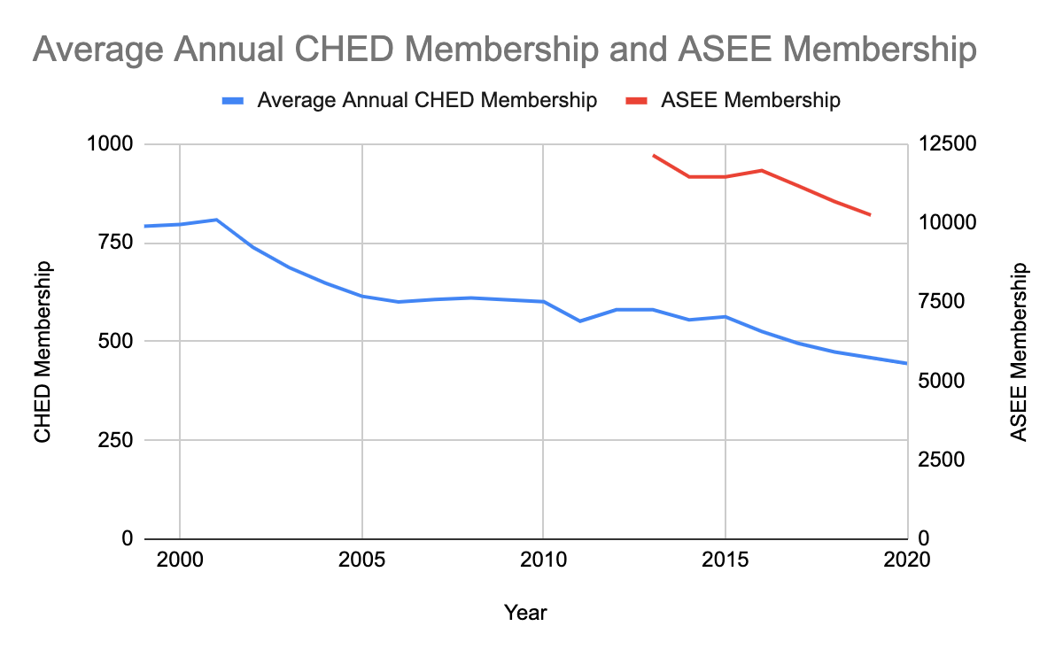
- Fundraising:
  - Nature of Contacts Made:
    - Instructional Hardware and Software Companies at ASEE & AIChE
    - Contacts with Industrial Representatives
  - Materials Provided:
    - Verbal Explanations: Nature of the Award & Approximate Donation Amount Expected
    - Formal Proposal from the CHED Secretary / Treasurer – Victoria Goodrich
  - Strategies to improve fundraising opportunities in 2022
    - Exhibitor area AIChE Annual Meeting (Nov. 2021)
    - University of Florida’s Career Fair (Sept 2021)
    - Industry contacts of ASEE – CHED
    - Alumni databases in selected Universities

- CDEI Updates
  - ASEE CDEI and Board have designated 2021-2022 as a year to create impact on Racial Equity in Engineering
  - Individual members may sign up to a task force or your division may choose a project for the year
  - To learn more and sign up see: https://diversity.asee.org/deicommittee/yire/
  - Awards: ASEE Constituent DEI Award and ASEE Best DEI Paper Award
- P-12 and the 2021-2022 Year of Impact on Racial Equity
- P-12 efforts in YIRE:
- Increased participation and comfort among black and brown P-12 children in pre-college engineering activities which communicate that an engineering career is an option for everyone
- Ways for P-12 Teachers to connect to ASEE’s P-12 efforts
  - Framework for P-12 Engineering Learning (https://p12framework.asee.org/)
  - P-12 Engineering Workshop (usually at the same time as annual conference, http://precollege.asee.org/pcee_conference/)
  - Engineering for Us All (https://e4usa.org/)

