Chemical Engineering Division
Executive Committee Meeting Minutes
Monday, June 25th, 2018 – 11:30 am – 1:00 pm
Room 250D Convention Center, Salt Lake City, UT
Attendees and Affiliations
Name | Affiliation | Current Position | Upcoming Position
Daniel Anastasio | Rose-Hulman | 2018 Program Chair
Cheryl Bodnar | Rowan | Secretary/Treasurer and Diversity Co-chair
Janie Brennan | Washington University in St. Louis |  | Director
Matthew Cooper | North Carolina State University | Director | Chair-Elect
Joshua Enszer | University of Delaware | Chair-Elect | Chair
Laura Ford | Tulsa | Past-Chair
Richard Gilbert | University of South Florida |  | 2019 Local Events Coordinator
Anju Gupta (on phone) | Rochester Institute of Technology | Membership Chair
Milo Koretsky | Oregon State University | Awards Co-Chair
David Silverstein | Kentucky | Past Summer School Chair (2017)
Bernie VanWie | Washington State | Past Awards Co-Chair
Margot Vigeant | Bucknell | Awards Co-Chair | Summer School Chair (2021)
Troy Vogel | Notre Dame | Chair | Past-Chair

- We introduced ourselves as above.
  - Election Results
    - Matthew Cooper was elected as incoming Division Chair
    - Janie Brennan was elected as incoming Director (2 year term)

  - Promotions, New Positions, Passing of Members
    - Joshua Enszer was promoted to Associate Teaching Professor

- Minutes from the last Executive Committee Meeting (October 30th, 2017 in Minneapolis, MN) were approved as submitted.

- Finances (Cheryl Bodnar) – a financial report is attached as Appendix 1.
- ASEE has now been able to complete their audits and all financial records are up to date and correspond with division records
- There are still some adjustments listed on this treasurer’s report due to the last round of audits that were performed since the 2017 June meeting
- We have received sponsorships from U.S. Didactic as well as CACHE to help support division activities and awards
- The BASS Admin Fee is equivalent to 30% of all net income that comes into the BASS (Banking and Account Service System) accounts. ASEE has been performing a verification study to determine how much employee time and effort goes into maintaining these accounts and after collection of six months worth of data it appears that the 30% level seems appropriate
- We are currently spending out slightly more than we are bringing in to the division but this is okay since ASEE would like us to spend down the BASS accounts where possible. These expenditures should be done on items that are of meaning to the division but could include food purchases for business or executive meetings, social events, etc.
- The dues on the ASEE website have been updated as of November. All members are now being charged $7 for division membership
- Our operating account funds align with how many individual members we have in the division. This has been going down in recent years but we could obtain more funds if we increase our overall membership.

- Updates
  - 2018 Annual Meeting (Daniel Anastasio)
    - Total of 49 abstracts were submitted to the conference this year. Out of these 1 abstract was rejected, 9 abstracts were withdrawn and five papers missed the draft deadline. This led to a total of 34 papers finalized for the program schedule
    - The 34 papers in the program are broken down as follows: 20 technical talks, 7 Work in Progress Postcard talks, 2 posters and 5 Work in Progress Posters.
    - There is also a panel happening this year between Matt Cooper and Milo Koretsky discussing adding rigor to your engineering education studies
    - There is no lectureship award session this year (there was a speaker that was approached but unfortunately unable to make this year’s meeting)
    - Key notes from this year’s program include reminding individuals to place “Work in Progress” in the title for ease of review. Also it would be helpful to reinforce the need to follow the paper guidelines, particularly those focused on works in progress, when submitting papers

  - 2018 Annual Meeting Awards Banquet (Dan Anastasio for Tony Butterfield)
    - At the time of the banquet all 40 tickets were sold (5 were sold the day of the banquet)
    - Tony will go by the restaurant (Cucina Toscana) early to make sure everything is in place

  - Awards (Margot Vigeant and Milo Koretsky)
    - Two mentoring awards, the best poster award, the best paper award for the ASEE 2017 conference and Chemical Engineering Education journal along with the CACHE award were presented this year (see Appendix 3)
    - The Distinguished Lectureship award has veered in recent years away from someone that is active in ASEE to more of an individual that just shows up, gives their lecture, and then leaves. For this reason, the awards committee proposed the combination of the Distinguished Lectureship award with the Lifetime Achievement Award to allow for an individual to be selected that has a strong vested interest in Chemical Engineering Education. Margot and Milo will put together a proposal and then circulate it for votes.
    - It was also mentioned that the awards committee would like nominations for awards to stay effective for at least 3 years. This will ease the burden on individuals that are nominating people for the awards. All individuals that are nominated (or their nominators) would be provided the opportunity to update their nomination packages before each new competition
    - Currently, the awards committee has a proposal with Exxon Mobil for sponsorship that they are waiting on hearing back about
    - The awards committee is also in conversation with Armstrong about sponsorship but they need to prepare a proposal for them
    - The awards committee has approached other companies that sponsored the summer school but unfortunately have not had success so far
    - Margot is looking for a volunteer who can judge the poster session tomorrow (Laura Ford mentioned she would volunteer)

  - Membership (Anju Gupta) – a membership report is attached as Appendix 2
  - We managed to get 6 new members this year
  - All of the ASEE divisions are seeing big declines in memberships
  - 395 professional members, 25 students, 3 K-12 educators, 53 other members for a total of 476 members
  - We are #4 in terms of membership after electrical, mechanical, civil engineering
  - We can have a table set up at the ASEE Division mixer that allows individuals to sign up and this way we can verify that they are selecting the ChE division in their sign ups
  - Anju is also chairing the Young Faculty Forum and will get word out about membership that way
  - Richard Gilbert suggested moving to a K-14 grouping that will allow individuals in community colleges to be able to sign up for membership
  - Our dues are still listed as $3 although they are supposed to be at $7 according to the vote 3 years ago (see Finances section that shows this was rectified as of November 2017)
  - Matt Cooper suggested we go back and look at attendees from the summer school and see who hasn’t signed up for ASEE ChE division membership
  - Milo Koretsky just mentioned e-mailing everyone that attended the summer school to see if they have signed up and to remind them that there is an extra box that needs to be checked to sign up for ChE Division membership
  - Josh Enszer will send out the e-mail after David Silverstein provides the list of attendees and e-mail addresses
  - Anju Gupta mentioned that with ASEE’s new communication policy it is possible that individuals may uncheck the reminder box which could cause more individuals to lapse in their membership
  - Anju did send out an e-mail to lapsed members to try to remind them to renew their division membership
  - Another suggestion was raised to have a booth at the graduate student fair at AIChE as a means to obtain new members
  - Richard Gilbert mentioned that targeting members of the Math division could be an additional source of members due to the amount of math built into chemical engineering

  - ASEE Diversity Delegate (Shannon Ciston via Troy)
    - Was not able to be present via phone
    - If any of the committee members have any questions or concerns they can reach out to her via e-mail

  - ASEE CEE Diversity Special Issue (Cheryl Bodnar)
    - The Diversity Special Issue came out in Spring 2018
    - It consisted of a perspective piece, a teaching piece, two editorials, and a series of research papers that discussed not only chemical engineering diversity in general but specific implementations ranging from K-12 to graduate education
    - The editors (Cheryl and Arthur) thank all the reviewers who helped throughout this process

  - Website (Tony Butterfield via Troy)
  - The website has been without incident for awhile
  - The latest word press seems to have fixed the gap
    - Tony has the archives in his possession back several years. Tony can’t just post the archives because there are materials there that have individual’s social security numbers present
    - David shared that several years ago they were given a box of records that included meeting minutes along with some award reimbursements. The award reimbursements have the confidential personal information. David mentioned that we need to keep the documents due to the historical value but Richard Gilbert was mentioning that it would be better to destroy the materials because it has personal information connected to it.
    - The archives have a lot of interesting information on publishing issues from back in the 60s and 70s with CEE. There is a lot of information built into there that would need to be gone through.
    - Richard Gilbert suggested that we get rid of all the electronic records (pdf copies). They are broken down by year so there is approximately 30 files.
    - Troy will ask Tony if he can give an estimate on the number of pages and how much it would take to redact the information. Floated the suggestion of one of Tony’s students doing the redaction of the personal information.

  - Newsletter Editor (Elif Miskioglu via Troy)
    - Preparing a formal document that will help ease transition in the future between newsletter editors
    - If previous newsletter editors have any suggestions or tips, it would be very helpful for future individuals

  - Summer School 2017 (David Silverstein)
    - Started off with $132,000 as an opening balance
    - Brought in an additional approximately $200,000 from industrial partners and NSF
    - Expenses were $211,517
    - Net Loss on the summer school ended up being $13,518. Over-spent intentionally, particularly on food, to draw down the balances
    - Current balance of the account is $118,366
    - Performed a lot of assessment including a survey that was recently sent out this month to get feedback. Based on the assessment performed all of the respondents mentioned that the summer school had some impact, most of it significant on their teaching. A lot of individuals mentioned that the summer school benefited their research and professional service as well.
    - Word cloud was generated that summarized the open-ended feedback received. Good words came out of this including active learning, techniques, etc.
    - Also did a word cloud in terms of service impact and found out that AIChE was higher represented than ASEE
    - Matt Cooper mentioned that individuals might be associating more with AIChE rather than ASEE due to the additional meet up this past October at AIChE and that it is easier for young faculty to participate in educational scholarship/research at AIChE.
    - David Silverstein mentioned that it would be helpful to have participants realize the beneficial nature of an ASEE membership
    - Richard Gilbert mentioned that participation in ASEE can really help with their broader impacts that need to be in all NSF proposals
    - Milo Koretsky mentioned that a workshop could be given on building an educational plan for a CAREER proposal
    - Bernie VanWie mentioned that he would be willing to offer this type of workshop (CAREER) or help with it at the future ChE Summer School

  - Past-chair (Laura Ford)
    - Coordinated with other people for the Martin Award

  - Incoming-chair (Josh Enszer)
    - Trying to identify aspects that are value added for why you may want to get ASEE ChE Division membership. Mentioned that he might include this as part of the general business meeting tomorrow. Margot mentioned something about this could be built into the open mic session during the conference
    - Matt Cooper mentioned that we should more broadly advertise the bring a student for free option
    - Milo Koretsky mentioned that we could do a more careful job of distinguishing between the AIChE education division and the ASEE ChE division.
    - Have a session next year in the program that would be focused on inter-disciplinary work (Matt Cooper). Milo mentioned that topics that are overarching in nature such as flipped classrooms would be a value add to the division. Troy mentioned that this type of coordination should be done at the programming chair level. Dan A. mentioned that there is no way to currently see papers from other divisions unless a programming chair reaches out and says do you want us to transfer this paper into your division
    - David mentioned that in the past there was a session at AIChE that was really research focused and provided a good overview of educational research techniques which helped keep ASEE and the ChE division at the forefront of participants at this conference
    - Janie Brennan mentioned that perhaps there should be representation at the student division or the meet the stars type events to help promote new members joining

- New Business

  - Summer School 2021 (Margot Vigeant, 2021 Summer School Chair)
  - The committee for the summer school has been formed and consists of:
    - Milo Koretsky
    - Laura Ford
    - Matt Liberatore
    - Taryn Bayles
    - Daniel Lepek
    - Daniel Burkey
    - Margot Vigeant (chair)
  - Call for proposals for a location to host the summer school has gone out to the chairs. Will also send this proposal out to all ChE Division members. Goal is to have a location selected prior to the AIChE meeting this fall
  - There is no need to have your chair’s approval for hosting the summer school just need the space availability
  - Had input from prior participants that five years between summer schools is a little too long given people’s tenure timelines
  - Have created a timeline for what is necessary to be able to get the summer school set up within the 4 year timeframe

  - 2019 conference in Tampa, FL (Troy Vogel)
    - Programming Chair: volunteer opening
      - Dan A. mentioned that he would be willing to help the new programming chair for Tampa
      - Note: At the time of the Business Meeting Reg Rogers agreed to serve in this capacity for the division
      - Also need to arrange for a programming chair and local events coordinator for the 2020 meeting in Montreal, Quebec, Canada
    - Local arrangements: Richard Gilbert
      - Richard suggested three potential options for the dinner:
        - Ulele which requires a river taxi trip up to the restaurant
        - A restaurant on the other side of the bridge (within walking distance of the hotels)
        - A Hispanic restaurant that would require either a trolley ride or shuttle from the hotels (this option allows for the presence of Flamenco dancers and would also be in a historic setting)
      - Concerns were raised about the cost of the options. The executive committee felt that keeping the cost of the ticket to $50-$60 was the most reasonable with having a target of 50 people attend
      - It was also mentioned that the restaurant selected needs to be cognizant of working with dietary restrictions as this could otherwise lead to limited attendance
      - Richard will take the time to price out all three of these options and then we can discuss at the next executive committee meeting in Pittsburgh this fall
      - Laura suggested that since we need to spend down the BASS funds we could have the division membership as a whole pay for award winner banquet tickets (through use of BASS funds) rather than just having the individuals attending the banquet cover these costs through their banquet ticket price

- Plan for Business Meeting
  - Troy shared the tentative agenda for the business meeting on Tuesday

Appendix 1 – Treasurer’s Report

American Society for Engineering Education Chemical Engineering Division
Treasurer's Report – June 2018

BASS Account total reported June 16, 2017 $17,016.10

Credits
Interest (FY17 Oct. 2016 – Sept. 2017) $10.86
Interest (FY18 Oct. 2017 – Dec. 2017) $1.11
Dues (January 2017 through September 2017) $1,070.00
Dues (October 2017 – March 2018) $1,441.00
2016 ASEE Banquet Revenue Correction $1,129.95
2017 Banquet Revenue $2,280.00
Sponsorships (U.S. Didactic Division Donation, June 2017) $1,000.00
Sponsorships (CACHE, May 2018) $1,200.00

$8,132.92

Debits
2017 Lectureship Travel $205.44
BASS Admin Fee Correction (June 2016 – Sept. 2016) $460.95
BASS Admin Fee (FY 17 Jan. 2017 – Sept. 2017) $574.23
BASS Admin Fee (FY 18 Oct. 2017 – Mar. 2018) $432.30
2017 Awards Banquet Reimbursement $2,435.90
2018 Awards – Fahien, Corcoran, CACHE, Portion of $4,430.00
Future Faculty
Reimbursement of Banquet Ticket for Corcoran Award Winner $60.00

$8,598.82

Total BASS Account (June 13, 2018) $16,550.20

Operating Account total reported June 16, 2017 $0.00

Credits

2017/2018 Allocation $470.00

Debits
Future Faculty Grant (Portion of grant; $900 total) $470.00
$0.00

Total Operating Account (June 13, 2018) $ 0.00

Appendix 2 – Membership Report
American Society for Engineering Education
COMMUNICATION Date: June 20, 2018

To: Executive Committee

From: Anju R Gupta, Membership Chair (2016- present)

Subject: CHE DIVISION MEMBERSHIP REPORT

RECOMMENDATION

Receive and file.

REPORT

I. CHED MEMBERS

Following data is from the ASEE CHE Division membership directory current and recent rosters (June 20, 6:15 pm).
Total members (Oct 2017) - 470
Total members (June 2018) – 476

The breakdown of the different types of members from the CHED current roster are as follows:

Member types | Jun 2018
Professional | 395
Student | 25
K-12 educator | 3
Others | 53
Total | 476

CHE Division members by the numbers (Jun 2010- Jun 2018)

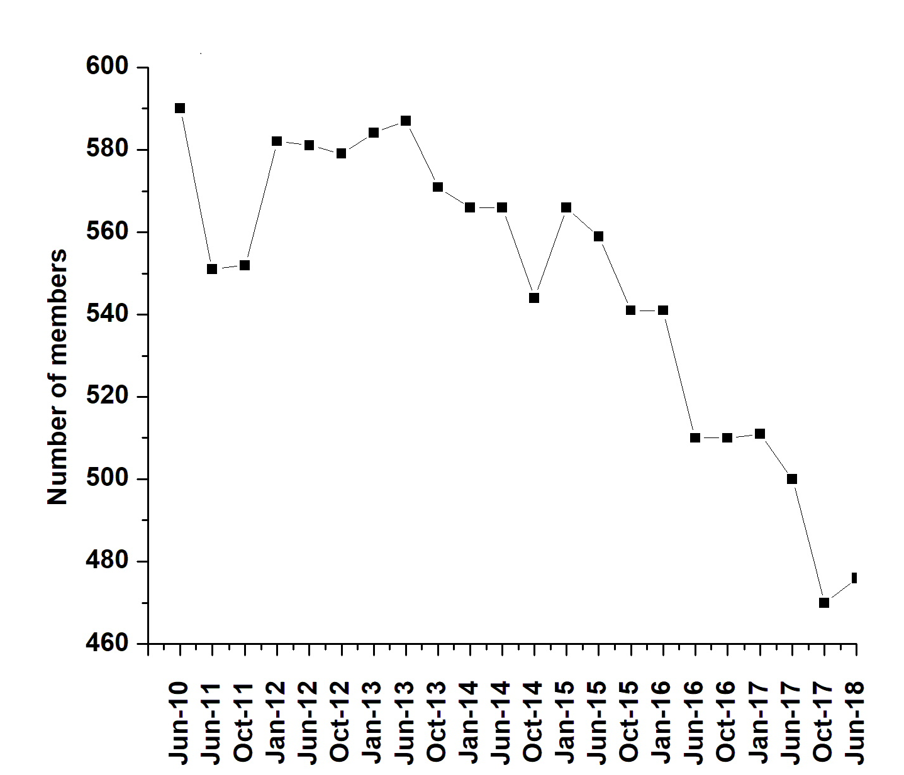

II. COMPARISON WITH OTHER DIVISIONS

Based on information received from ASEE staff and ASEE Annual PIC meeting June 2018-

DIVISION | MEMBERS
Aerospace Engineering (PIC I) | 297
Architectural Engineering (PIC I) | 237
Biological and Agricultural Engineering (PIC I) | 129
Biomedical Engineering (PIC II) | 491
Chemical Engineering (PIC I) | 476
Civil Engineering (PIC I) | 540
College Industry Partnerships (PIC V) | 523
Community Engagement (PIC III) | 819
Computers in Education (PIC IV) | 408
Computing & Information Technology (PIC III) | 874
Construction Engineering (PIC I) | 124
Continuing Professional Development (PIC V) | 160
Cooperative & Experiential Education (PIC V) | 220
Design in Engineering Education (PIC II) | 893
Educational Research and Methods (PIC IV) | 1452
Electrical and Computer Engineering (PIC I) | 758
Energy Conversion and Conservation (PIC III) | 1150
Engineering and Public Policy (PIC III) | 198
Engineering Design Graphics (PIC III) | 167
Engineering Economy (PIC I) | 110
Engineering Ethics (PIC IV) | 1254
Engineering Leadership Development (PIC II) | 1113
Engineering Libraries (PIC IV) | 213
Engineering Management (PIC I) | 241
Engineering Physics and Physics (PIC III) | 187
Engineering Technology (PIC II) | 464
Entrepreneurship (PIC IV) | 377
Environmental Engineering (PIC II) | 327
Experimentation and Lab.-Oriented Studies (PIC IV) | 312
Faculty Development (PIC IV) | 207
First-Year Programs (PIC III) | 541
Graduate Studies (PIC IV) | 253
Industrial Engineering (PIC I) | 239
Instrumentation (PIC III) | 131
International (PIC IV) | 218
Liberal Education/Engineering & Society (PIC III) | 344
Manufacturing (PIC I) | 232
Materials Engineering (PIC II) | 813
Mathematics (PIC III)s | 176
Mechanical Engineering (PIC I) | 821
Mechanics (PIC III) | 303
Military and Veterans (PIC II) | 250
Minorities in Engineering (PIC IV) | 547
Multidisciplinary Engineering (PIC II) | 1389
New Engineering Educators (PIC IV) | 278
Nuclear and Radiological Engineering (PIC II) | 78
Ocean and Marine Engineering (PIC II) | 206
Pre-College Engineering Education (PIC IV) | 592
Software Engineering (PIC II) | 305
Student (PIC IV) | 695
Systems Engineering (PIC II) | 256
Tech. & Engr. Literacy/Philosophy of Engr. (PIC III) | 625
Two-Year College (PIC III) | 389
Women in Engineering (PIC IV) | 872
Total | 24530

Appendix 3 – Awards Brochure

