Chemical Engineering Division
Business Meeting Minutes
Tuesday, June 26, 2018 – 5:00 PM – 6:00 PM
150E Convention Center, Salt Lake City, UT

Attendees and Affiliations
Daniel Anastasio | Rose-Hulman
Chris Barr | University of Michigan
Taryn Bayles | University of Pittsburgh
Cheryl Bodnar | Rowan
Michael Borankin | Colorado School of Mines
Janie Brennan | Washington University in St. Louis
Lisa Bullard | North Carolina State
Daniel Burkey | University of Connecticut
Tracy Carter | Northeastern
Heather Chenette | Rose-Hulman
Matthew Cooper | North Carolina State
Kevin Dahm | Rowan
Michael Elsass | Dayton
Joshua Enszer | University of Delaware
Laura Ford | Tulsa
Kevin Hadley | Arizona State University
Mechteld Hillsley | Penn State
Joseph Holles | University of Wyoming
Julie Jessop | Mississippi State University
Jason Keith | Mississippi State University
Eugene Kim | Washington University in St. Louis
Daniel Knight | University of California, Irvine
Monica Lamm | Iowa State University
Lucas Landherr | Northeastern University
Randy Lewis | Brigham Young University
Matt Liberatore | University of Toledo
Andy Maxson | Ohio State
Adam Melvin | Louisiana State University
Elif Miskioglu | Bucknell University
Greg Neumann | Rose-Hulman
Christi Patton Luks | Missouri S & T
Reginald Rogers | Rochester Institute of Technology
Joe Shaeiwitz | Auburn
Trent Silbaugh | Washington University in St. Louis
David Silverstein | Kentucky
Marissa Tousley | Rose-Hulman
Bernard Van Wie | Washington State
Margot Vigeant | Bucknell
Troy Vogel | Notre Dame
Jason White | UC Davis

- We circulated a sign-up sheet due to the full meeting (see names listed above).

  - Promotions, New Positions, Passing of Members
    - Joshua Enszer was promoted to Associate Teaching Professor
    - Kevin Hadley moved to a Lecturer Position at Arizona State University
    - Reg Rogers promoted to tenured Associate Professor
    - Julie Jessop promoted to Professor and Associate Chair as part of her move to Mississippi State University

- Minutes from the last Business Meeting (June 27th, 2017 in Columbus, OH) were approved as submitted.

- Ongoing Business

  - Election Results
    - Matthew Cooper was elected as incoming Division Chair
    - Janie Brennan was elected as incoming Director (2 year term)
  - Finances (Cheryl Bodnar) – a financial report is attached as Appendix 1.
- ASEE has now been able to complete their audits and all financial records are up to date and correspond with division records
- There are still some adjustments listed on this treasurer’s report due to the last round of audits that were performed since the 2017 June meeting
- We have received sponsorships from U.S. Didactic as well as CACHE to help support division activities and awards
- The BASS Admin Fee is equivalent to 30% of all net income that comes into the BASS (Banking and Account Service System) accounts. ASEE has been performing a verification study to determine how much employee time and effort goes into maintaining these accounts and after collection of six months worth of data it appears that the 30% level seems appropriate
- We are currently spending out slightly more than we are bringing in to the division but this is okay since ASEE would like us to spend down the BASS accounts where possible. These expenditures should be done on items that are of meaning to the division but could include food purchases for business or executive meetings, social events, etc.
- The dues on the ASEE website have been updated as of November. All members are now being charged $7 for division membership
- Our operating account funds align with how many individual members we have in the division. This has been going down in recent years but we could obtain more funds if we increase our overall membership.

  - Membership (Troy Vogel)
    - We managed to get 6 new members this year
    - All of the ASEE divisions are seeing big declines in memberships
    - 395 professional members, 25 students, 3 K-12 educators, 53 other members for a total of 476 members
    - We are #4 in terms of membership after electrical, mechanical, civil engineering
    - We should try to leverage the Dean and Chairs program that allows a new ASEE member to have two years of membership paid for if the Dean is agreeable. The Dean pays for the first year and ASEE pays for the second year. Ask your ASEE campus representative about this opportunity for more details
    - Additional membership notes are outlined in the memo in Appendix 2

  - PIC I Update (Agnieszka Miguel)
    - Provided info to officers that could be shared more broadly with division members
    - Conference code of conduct is a key point of discussion at the PIC level
      - Don’t know what should be done if someone violates the code that has been put in place
      - Ethics task force will be looking into this and other issues such as plagiarism this year
    - Finances are in good shape for ASEE overall. ASEE was able to put $350,000 in reserves in 2017 and it appears that we are on track for the same type of savings for 2018 as well. ASEE’s credit rating has also improved
    - ASEE is encouraging the divisions to have a plan about what they will do with their BASS accounts
    - Updates to bylaws should be made every 10 years
    - PIC I is trying to update their bylaws and consolidate them
    - 3,800 attendees at this year’s ASEE meeting in comparison to 4,026 last year. ASEE is losing members at a rate of about 400 individuals per year. There is another task force that is being assembled to look at this issue. One area of potential interest is to determine how to attract two year colleges to become members
    - Feedback provided by ChE Division members:
      - Individuals running workshops wanted to know who had registered for their workshop (not just the number of individuals)
      - It would be beneficial to allow individuals to do late withdrawals
      - Is it possible for Works in Progress to only require an abstract rather than a full paper
      - It was very helpful to have the childcare option available. Advertising this earlier in the conference registration process may encourage better attendance at the conference
      - Online session locator (monolith) isn’t the easiest system to work with for identifying papers. It would also be helpful to have an app for the conference rather than just an online system
      - It would also be helpful to know the timing of the talks between the different divisions so individuals can more easily move from one division to another.
  - 2018 Annual Meeting (Daniel Anastasio)
    - Total of 49 abstracts were submitted to the conference this year. Out of these 1 abstract was rejected, 9 abstracts were withdrawn and five papers missed the draft deadline. This led to a total of 34 papers finalized for the program schedule
    - The 34 papers in the program are broken down as follows: 20 technical talks, 7 Work in Progress Postcard talks, 2 posters and 5 Work in Progress Posters.
    - There is also a panel happening this year between Matt Cooper and Milo Koretsky discussing adding rigor to your engineering education studies
    - At the time of the banquet all 40 tickets were sold (5 were sold the day of the banquet). Important note is that the awards banquet is for everyone not just those individuals that may have won an award
    - Daniel thanked the authors and reviewers for their time invested in the paper process
    - Any additional comments on how to improve the programming can be provided to Daniel who will communicate it to the new programming chair

  - Awards (Margot Vigeant)
    - Two mentoring awards, the best poster award, the best paper award for the ASEE 2017 conference and Chemical Engineering Education journal along with the CACHE award were presented this year (see Appendix 3)
    - The Distinguished Lectureship award has veered in recent years away from someone that is active in ASEE to more of an individual that just shows up, gives their lecture, and then leaves. For this reason, the awards committee proposed the combination of the Distinguished Lectureship award with the Lifetime Achievement Award to allow for an individual to be selected that has a strong vested interest in Chemical Engineering Education. Margot and Milo will put together a proposal and then circulate it for votes.
    - Division members were encouraged to nominate themselves or someone they know for the division awards
    - Deadline for all mentorship awards is in October (both require an abstract submission) but the other division awards have deadlines in January

  - Summer School 2017 (David Silverstein)
    - Had 174 participants with 227 attendees in total
    - Started off with $132,000 as an opening balance
    - Brought in an additional approximately $200,000 from industrial partners and NSF
    - Expenses were $211,517
    - Net Loss on the summer school ended up being $13,518. Over spent intentionally, particularly on food, to draw down the balances
    - Current balance of the account is $118,366
    - David thanked key members of the summer school committee including Jason Keith for his work on sponsorships, Lisa Bullard for her assistance with local arrangements, Kevin Dahm for his assistance with programming, and Matt Cooper for his assistance with social events. Troy Vogel was also an asset in arranging the industry day that was held in conjunction with the summer school
    - Performed a lot of assessment including a survey that was recently sent out this month to get feedback. Based on the assessment performed all of the respondents mentioned that the summer school had some impact, most of it significant on their teaching. A lot of individuals mentioned that the summer school benefited their research and professional service as well.
    - Word cloud was generated that summarized the open ended feedback received. Good words came out of this including active learning, techniques, etc.

- New Business

  - Summer School 2021 (Margot Vigeant, 2021 Summer School Chair)
  - The committee for the summer school has been formed and consists of:
    - Milo Koretsky
    - Laura Ford
    - Matt Liberatore
    - Taryn Bayles
    - Daniel Lepek
    - Daniel Burkey
    - Margot Vigeant (chair)
  - Call for proposals for a location to host the summer school has gone out to the chairs. Will also send this proposal out to all ChE Division members (https://goo.gl/forms/kfSq1DPSXjYa5pBs1). Goal is to have a location selected prior to the AIChE meeting this fall
  - There is no need to have your chair’s approval for hosting the summer school just need the space availability
  - Had input from prior participants that five years between summer schools is a little too long given people’s tenure timelines
  - Have created a timeline for what is necessary to be able to get the summer school set up within the 4 year timeframe
  - More information can be found at: chesummerschool.org
  - Lisa Bullard mentioned that she would be a resource for anyone that is interested in hosting the local arrangements

  - 2019 conference in Tampa, FL (Troy Vogel)
    - Programming Chair 2019: volunteer opening
      - Dan A. mentioned that he would be willing to help the new programming chair for Tampa
      - Note: At the time of the Business Meeting Reg Rogers agreed to serve in this capacity for the division
      - Also need to arrange for a programming chair and local events coordinator for the 2020 meeting in Montreal, Quebec, Canada
    - Secretary/Treasurer 2019-2021 (elected position; volunteer opening)

- Brainstorming about ASEE ChED
  - There were four topical focuses for the brainstorming session with comments in each:
    - Determine one session theme you would like to see solicited
      - Session on Unit Operations/Senior Design (focus on process safety)
      - More collaboration between ChED and MIND
      - UG/Grad Research Session (could include UGs presenting technical aspects and learning, UGs present technical topics, faculty speak about experiences managing/advising UGs in the lab
      - Assessment workshop or talks – going beyond self-assessment of learning
      - Hands on learning
      - Interdisciplinary Teaching (MechE/Civil/Etc.) with ChemE
      - Question to ponder: Why are most popular textbooks just revised versions of 25-40 year old texts?
      - Rotating topic workshop on best practices in teaching Chemical Engineering classes. (If we use authors, must invite competing book authors) – maybe a panel of authors plus other teachers, maybe related to the AIChE survey, could lead to CEE papers
    - Determine an approach to grow membership in ChED
      - How are ASEE campus reps used? (can they do graduate student outreach?) More proactively?
      - Outreach at AICHE – future faculty poster session/meet the faculty candidates! – provide sponsorship or awards to attend ASEE?
      - Develop a member/get a member campaign
      - Articulate the value of membership (networking)
      - More AICHE/ASEE interaction? (have a “best of” invitation only session in the opposite?)
    - Determine an approach to encourage “non-active” members to be more active
      - Encourage more collaborators between universities (possibly a session geared toward inter-university collaboration)
      - Solicit nominations for positions
      - Group teambuilding exercises to help (more social events) encourage more people to volunteer
      - Share membership between AICHE Ed Div?
      - Peer mentor program?
      - Decrease the requirement to 1 page for Work in Progress
      - Where is the ‘non-activity’? – run the numbers and get the data
    - Determine an approach to make divisions more interconnected and collaborative
      - Use the PIC Chairs as a mechanism for more interconnectedness? They have access to all of the papers and topics – PIC Chairs have sessions where anyone can put a paper into? This would be based on a topic area.
      - PIC call for papers as opposed to individual divisions?
      - Workshops and panels across divisions
      - Division Programming chairs look at each other’s call for papers and see if there are themes for a session across divisions
      - Sessions across divisions (eg. design projects with students in multiple disciplines)
      - How much can program chairs connect with one another?
      - Actively look for more co-sponsoring (diversity/global outreach session could have been co-sponsored)
      - Faculty development/eng. education research session (there were many non-ChE’s at the education research panel)
      - Session on a topic rather than a discipline (flipped classrooms, teamwork, ethics, trust…)
      - Focus on common courses among disciplines (fluids, thermodynamics, etc.)
- Troy passed the “golden wrench” to Josh Enszer – incoming Division Chair

Appendix 1 – Treasurer’s Report

American Society for Engineering Education Chemical Engineering Division
Treasurer's Report – June 2018

BASS Account total reported June 16, 2017 $17,016.10

Credits
Interest (FY17 Oct. 2016 – Sept. 2017) $10.86
Interest (FY18 Oct. 2017 – Dec. 2017) $1.11
Dues (January 2017 through September 2017) $1,070.00
Dues (October 2017 – March 2018) $1,441.00
2016 ASEE Banquet Revenue Correction $1,129.95
2017 Banquet Revenue $2,280.00
Sponsorships (U.S. Didactic Division Donation, June 2017) $1,000.00
Sponsorships (CACHE, May 2018) $1,200.00

$8,132.92

Debits
2017 Lectureship Travel $205.44
BASS Admin Fee Correction (June 2016 – Sept. 2016) $460.95
BASS Admin Fee (FY 17 Jan. 2017 – Sept. 2017) $574.23
BASS Admin Fee (FY 18 Oct. 2017 – Mar. 2018) $432.30
2017 Awards Banquet Reimbursement $2,435.90
2018 Awards – Fahien, Corcoran, CACHE, Portion of $4,430.00
Future Faculty
Reimbursement of Banquet Ticket for Corcoran Award Winner $60.00

$8,598.82

Total BASS Account (June 13, 2018) $16,550.20

Operating Account total reported June 16, 2017 $0.00

Credits

2017/2018 Allocation $470.00

Debits
Future Faculty Grant (Portion of grant; $900 total) $470.00
$0.00

Total Operating Account (June 13, 2018) $ 0.00

Appendix 2 – Membership Report
American Society for Engineering Education
COMMUNICATION Date: June 20, 2018

To: Executive Committee

From: Anju R Gupta, Membership Chair (2016- present)

Subject: CHE DIVISION MEMBERSHIP REPORT

RECOMMENDATION

Receive and file.

REPORT

I. CHED MEMBERS

Following data is from the ASEE CHE Division membership directory current and recent rosters (June 20, 6:15 pm).
Total members (Oct 2017) - 470
Total members (June 2018) – 476

The breakdown of the different types of members from the CHED current roster are as follows:

Member types | Jun 2018
Professional | 395
Student | 25
K-12 educator | 3
Others | 53
Total | 476

CHE Division members by the numbers (Jun 2010- Jun 2018)

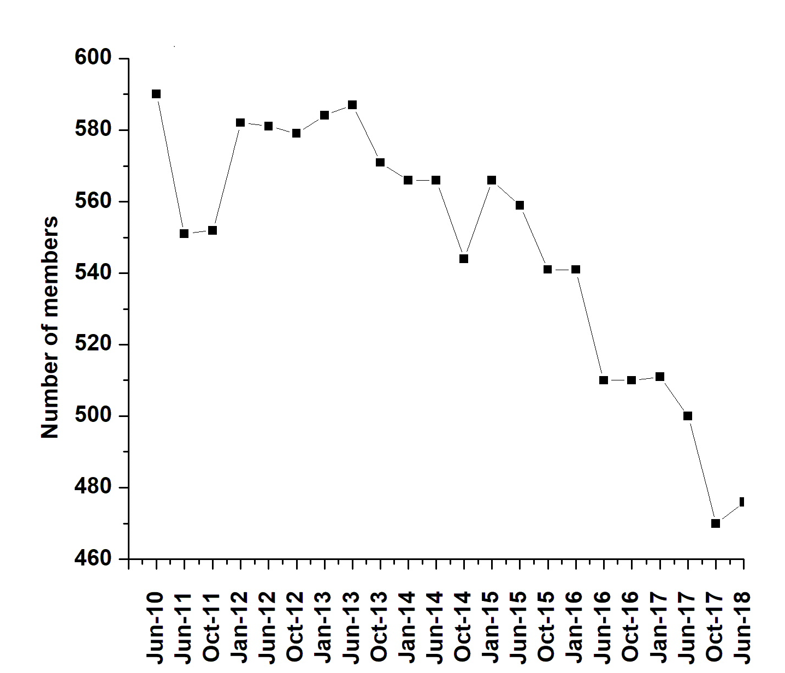

II. COMPARISON WITH OTHER DIVISIONS

Based on information received from ASEE staff and ASEE Annual PIC meeting June 2018-

DIVISION | MEMBERS
Aerospace Engineering (PIC I) | 297
Architectural Engineering (PIC I) | 237
Biological and Agricultural Engineering (PIC I) | 129
Biomedical Engineering (PIC II) | 491
Chemical Engineering (PIC I) | 476
Civil Engineering (PIC I) | 540
College Industry Partnerships (PIC V) | 523
Community Engagement (PIC III) | 819
Computers in Education (PIC IV) | 408
Computing & Information Technology (PIC III) | 874
Construction Engineering (PIC I) | 124
Continuing Professional Development (PIC V) | 160
Cooperative & Experiential Education (PIC V) | 220
Design in Engineering Education (PIC II) | 893
Educational Research and Methods (PIC IV) | 1452
Electrical and Computer Engineering (PIC I) | 758
Energy Conversion and Conservation (PIC III) | 1150
Engineering and Public Policy (PIC III) | 198
Engineering Design Graphics (PIC III) | 167
Engineering Economy (PIC I) | 110
Engineering Ethics (PIC IV) | 1254
Engineering Leadership Development (PIC II) | 1113
Engineering Libraries (PIC IV) | 213
Engineering Management (PIC I) | 241
Engineering Physics and Physics (PIC III) | 187
Engineering Technology (PIC II) | 464
Entrepreneurship (PIC IV) | 377
Environmental Engineering (PIC II) | 327
Experimentation and Lab.-Oriented Studies (PIC IV) | 312
Faculty Development (PIC IV) | 207
First-Year Programs (PIC III) | 541
Graduate Studies (PIC IV) | 253
Industrial Engineering (PIC I) | 239
Instrumentation (PIC III) | 131
International (PIC IV) | 218
Liberal Education/Engineering & Society (PIC III) | 344
Manufacturing (PIC I) | 232
Materials Engineering (PIC II) | 813
Mathematics (PIC III)s | 176
Mechanical Engineering (PIC I) | 821
Mechanics (PIC III) | 303
Military and Veterans (PIC II) | 250
Minorities in Engineering (PIC IV) | 547
Multidisciplinary Engineering (PIC II) | 1389
New Engineering Educators (PIC IV) | 278
Nuclear and Radiological Engineering (PIC II) | 78
Ocean and Marine Engineering (PIC II) | 206
Pre-College Engineering Education (PIC IV) | 592
Software Engineering (PIC II) | 305
Student (PIC IV) | 695
Systems Engineering (PIC II) | 256
Tech. & Engr. Literacy/Philosophy of Engr. (PIC III) | 625
Two-Year College (PIC III) | 389
Women in Engineering (PIC IV) | 872
Total | 24530

Appendix 3 – Awards Brochure

