ASEE_Logo_Long_Black.jpg

Chemical Engineering Division

Executive Committee Meeting Minutes

Monday, June 15, 2015 – 7:00 – 8:30 am

Washington State Convention Center, Room 208, Seattle, WA

Attendees and Affiliations

|  |  |  |  |
| --- | --- | --- | --- |
| Name | Affiliation | Current Position | Upcoming Position |
| Cheryl Bodnar | Rowan | Diversity Co-chair | Secretary/Treasurer |
| Lisa Bullard | North Carolina State | Chair | Past-chair |
| Matthew Cooper | North Carolina State | Newsletter Editor |  |
| Kevin Dahm | Rowan | Program Chair |  |
| David Dixon | South Dakota School of Mines | Past-chair |  |
| Michael Elsass | Dayton | Director |  |
| Arthur Felse | Northwestern | Diversity Co-Chair | Program Chair |
| Laura Ford | Tulsa | Secretary/Treasurer | Chair-elect |
| Allen Hersel | Trine | Membership |  |
| Milo Koretsky | Oregon State |  | Director |
| Christi Patton Luks | Missouri S & T | Chair-elect | Chair |
| Adrienne Minerick | Michigan Tech | PIC I Chair |  |
| David Silverstein | Kentucky | Webmaster |  |
| Bernard VanWie | Washington State | Awards Co-chair |  |

1. We introduced ourselves as above. Lisa welcomed the new officers (Cheryl Bodnar, Laura Ford, and Milo Koretsky) and thanked those rotating out (David Dixon and Daniel Lepek). We collected information on new positions and promotions to announce at the Business Meeting:

Cheryl Bodnar – Rowan

Allen Hersel – Provost (VP of Academic Affairs) at Trine

Jason Keith – Dean of Engineering at Mississippi State

Adrienne Minerick – Associate Dean for Research and Innovation at Michigan Tech

Dick Zollars – retired from Washington State

2. Minutes from the last Executive Committee Meeting (November 17, 2014 in Atlanta, GA) were approved as submitted.

3. Ongoing Business

1. Finances (Laura Ford) – a financial report is attached as Appendix 1. [Prior to this meeting, a message had been sent to division chairs and secretary/treasurers about ASEE’s financial practices, budgetary problems, and a new indirect cost of 60% to be applied to all BASS account expenses starting in October 2015.] At the Board Meeting on Saturday, the Board decided to change to a 30% indirect cost on all income to the BASS accounts. According to Adrienne at the PIC I meeting, banquet tickets are proposed to pass through Operating accounts instead of BASS accounts. 30% of income will cover the $65,000 for the staff member working with BASS accounts. If we wish to change dues, we must change our bylaws by December 1. Armfield, a possible Lectureship sponsor, has been agreeable to 5% IDC but no higher. Our dues are currently $3. $5 dues would cover the 30% IDC; $10 gives us funds for recruitment.
2. Membership (Allen Hersel) – Adrienne said that membership is declining, but Allen disagreed, at least for our division over the past year. We have declined over the past 7 or 8 years. [We were distracted and moved on; a full membership report is given in the minutes of the Business Meeting.]

4. Updates

a. Program (Kevin Dahm) – 49 abstracts were submitted with 32 final papers. We have 3 panel discussions, 1 workshop, the Chemstations Lectureship, 1 poster session, and 5 podium sessions. There were no paper fees this year, but registration fees went up.

b. Awards Banquet (Kevin Dahm) – we have about 50 tickets sold to the banquet. We’ll socialize from 6:00 to about 6:30 and plan to start serving about 6:30. Please welcome new faces.

c. Awards (Bernie VanWie) – Bernie recognized the work of his co-chair, Joe Menicucci. The awardees are given in the brochure attached as Appendix 2. There was only 1 applicant for some awards and not a single application for the Lifetime Achievement Award or two of the mentoring awards. Lisa sent a note to all department chairs; was mention made at the AIChE chairs meeting, too? The Awards Committee will consider consolidating the 3 mentoring awards into one award at a higher amount with young faculty and graduate students both eligible. We developed a starting list of people to encourage others to nominate for the Lifetime Achievement Award: Tom Edgar, John Falconer, Milo Koretsky, Angie Perna, Joe Shaeiwitz, Stuart Slater, and Dick Zollars. Can we keep nominations active for multiple (how many) years? An endowment of $50,000 was mentioned as a possible funding source for the Corcoran Award.

d. Diversity Committee (Arthur Felse) – Arthur gave an update on the diversity of chemical engineers and our division. We are the only division with a diversity committee. 12 divisions made a bylaws change to include diversity (as we did). The diversity committee on Wednesday wound up being one on gender diversity; maybe we can do an ethnic diversity one next year. The committee is working on a diversity issue for Chemical Engineering Education. Four of the abstracts for this conference were flagged as diversity related.

e. Summer School (David Silverstein) – The next Summer School for Chemical Engineering Faculty will be held in July 29 – Aug. 4, 2017, in Raleigh, NC. The committee is planning for 200 attendees but may have more. They are considering a day of soft skills workshops, run by the people who teach the same thing to industry. NSF has agreed to funding.

5. New Business

a. Adrienne Minerick reported for PIC I. The Board now has electronic voting available to them, and we can consider if we want to change our voting policies. ABET has a comment period open, specifically on Criteria 3 and 5, ending on July 1. The Diversity Committee encourages people to comment on the lack of diversity of pictures on their website. You can also get information to the ABET representative for AIChE [Said Abubakr, Sue Ann Allen, Gary Foutch, Roland Heck, Randy Lewis, and Michael Prudich]. The Strategic Doing and Listening session is Tuesday, with a goal of flattening ASEE’s hierarchical structure. Our best diversity paper was one of the best 6, so it will be in the best diversity session on Monday.

b. Volunteer Opportunities

* + 1. New Orleans 2016 – Arthur Felse, Program Chair; ?, Local Arrangements
    2. Columbus, OH 2017 – ?; Program Chair; ?, Local Arrangements

6. Lisa thanked us for all of our work.

Appendix 1

American Society for Engineering Education Chemical Engineering Division

Treasurer's Report – June 2015

**BASS Account total reported June 12, 2014 $35,597.07**

# Credits

Interest (none posted for Oct. 2013 to date) $

Dues (April 2014 through January 2015) $1,314.00

Sponsorships (Eastman Corcoran, 2014; CACHE 2015) $3,200.00

2014 Banquet Revenue $3,190.00

$7,704.00

# Debits

Part of 2014 Plaques ($1,337.30 total) $1,220.30

2014 Awards Banquet $3,302.40

2015 Awards (CACHE, Lectureship, Corcoran, Fahien) $7,000.00

Part of 2015 Plaques ($1,303 total) $1,237.00

$12,759.70

[What the debits would be with the 60% indirect costs $20,415.52]

**Total BASS Account** (June 17, 2015) **$30,541.37**

**Operating Account total reported June 12, 2014 $ 117.00**

# Credits

# 2014/2015 Allocation $566.00

# Debits

Part of 2014 Plaques ($1,337.30 total) $117.00

2015 Future Faculty Award $500.00

Part of 2015 Plaques ($1,303 total) $66.00

$683.00

**Total Operating Account** (June 17, 2015) **$ 0.00**

**Joseph J. Martin Award**

(for the best paper in the ChE Division at the previous ASEE meeting that also appears in the proceedings)

Alec S. Bowen, Daniel R. Reid, and Dr. Milo Koretsky (Oregon State University) are recognized for their paper:

"Development of Interactive Virtual Laboratories to Help Students Learn Difficult Concepts in Thermodynamics".

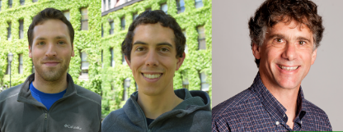

**CACHE Award**

(for contributions to computing in chemical engineering)

# Sponsored by the CACHE Corporation

Dr. George Stephanopoulos

Massachusetts Institute of Technology

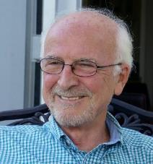George Stephanopoulos is the Arthur D. Little Professor of Chemical Engineering at the Massachusetts Institute of Technology. He was awarded the CACHE Award for Excellence in Computing in Chemical Engineering Education for the development of computer aids in chemical engineering education, through the generation of software packages and the writing and editing of associated learning materials and books in computer-aided chemical engineering education.

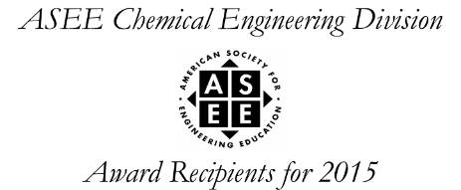

ASEE Annual Conference

Seattle, Washington

**Chemstations Lectureship Award**

# Sponsored by Chemstations, Inc.

Dr. Ignacio E. Grossmann

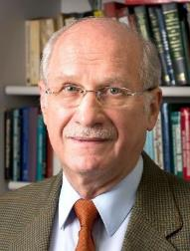Professor Ignacio E. Grossmann, the Rudolph R. and Florence Dean University Professor of Chemical Engineering and former Department Head at Carnegie Mellon University, has made significant, pioneering contributions to systematic methods in process synthesis, optimal decision-making under uncertainty and process logistics including planning and scheduling across the chemical processing enterprise. His outstanding contributions have had significant impacts in power generation, energy management systems, resource conservation and the optimization of batch and continuous processes for chemical, food and pharmaceutical production. They have also opened up new research vistas and made tremendous impact in engineering practice. His contributions to education include mentoring 48 PhDs, with a quarter of them in academia, a groundbreaking textbook, and far-reaching web-based educational materials and software.

# **Best Poster Award Winner**

# (for the best poster in the ChE Division at the previous ASEE meeting)

# Dr. Cheryl A. Bodnar, Dr. Eric J. Beckman, Dr. Joseph J. McCarthy, and

# Dr. Steven R. Little (University of Pittsburgh)

# ‘Work in Progress: A Vision for the First “Product Innovation Sequence” for Chemical Engineers’

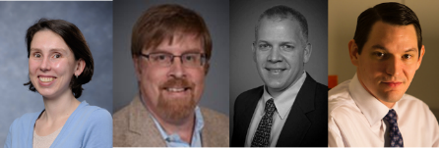

# **Ray W. Fahien Award**

(for outstanding teaching effectiveness and educational scholarship for faculty members in their first 10 years)

Dr. Daniel H. Lepek (The Cooper Union)

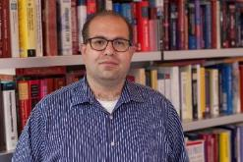Daniel Lepek, Associate Professor of Chemical Engineering at The Cooper Union, is a leader in chemical engineering education and a major proponent of leveraging technology to improve student learning. Since joining The Cooper Union, he has taught 10 different courses and has been very active in the ASEE Chemical Engineering Division, having served as Program Chair for the 2013 Annual Conference and Division Director from 2013-2015. Since receiving the 2011 “Engineering Education” Mentoring Grant, he has published two peer-reviewed conference proceedings and currently has a chemical engineering textbook under contract. His current educational research is focused on peer instruction, technology-enhanced active learning, and electronic textbooks.

# **William H. Corcoran Award**

(for the best paper published in the previous calendar year in *Chemical Engineering Education*)

*Sponsored by Eastman Chemical Corporation*

David D. Shaw and Dr. Leonard F. Pease III (University of Utah)

"Efficient Grading"

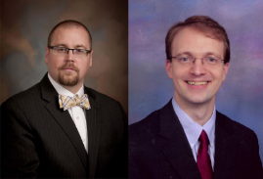

**ChE Division Graduate Student Future Faculty Grant**

(for chemical engineering graduate students who have not presented at an ASEE Annual Conference)

Kenneth P. Mineart (North Carolina State University)



In the large Unit Operations laboratory course at North Carolina State University, graduate student Kenneth Mineart demonstrated an uncommon drive to help students learn, and received positive reviews from students during the student course evaluation process. As Kenneth has progressed through his graduate career, he has demonstrated a genuine interest in teaching. He is enrolled in NCSU's "Preparing the Professoriate" program, which intends to groom the next generation of engineering educators for excellence in the classroom. He is co-author of *Improving Student Technical Communication via Self Reflection*, a paper in the 2015 ASEE Annual Meeting.